Technical Design

TrafficLights

Learning unit: TrafficLights BT1

Version number: 0.1

Author(s): Cody Strijbosch

# Version Control

|  |  |  |  |
| --- | --- | --- | --- |
| Date | Version | Changes | Who |
| 30-6-2017 | 0.1 | - | Cody Strijbosch |
|  |  |  |  |
|  |  |  |  |

# Contents list

Version Control 2

Contents list 3

Introduction 4

Schedule 4

Akkoord leidinggevende/Projectleider 7

# Introduction

The goal of this document is to get an understanding about the different techniques that are going to be used at developing the desired software. Besides that there will be a clear image drawn about the different techniques that are connected to each other. This document is made for this project so everyone that gets involved will find it easier to find his way in the already existing architecture and software functions.

The project is an traffic light system. This system will be used if there is no other traffic regulation. It is developed in an embedded system called Arduino. The software language is C/C++ written in the Arduino IDE software.

# Schedule

For this document I planned a time limit of 3-5 hours because it’s my second time making it.

Software architecture

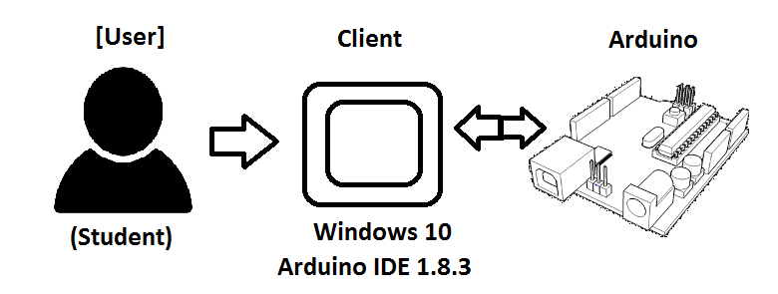

Application Flow

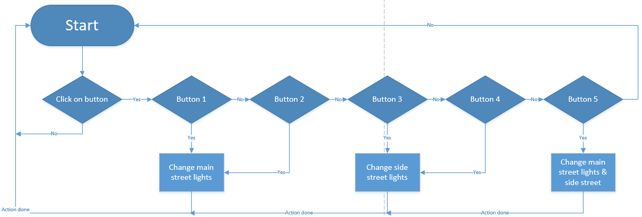

Activity Diagrams

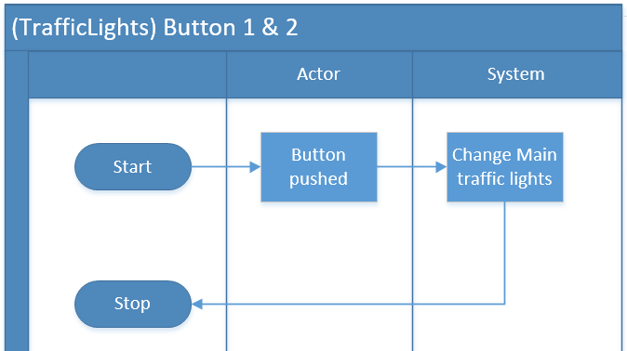

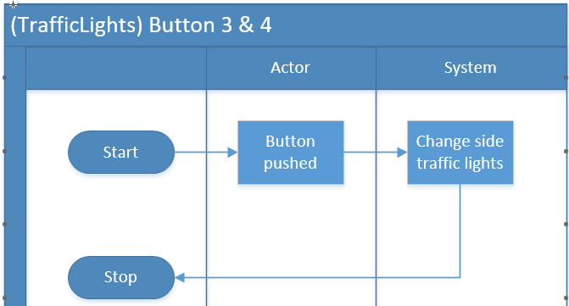

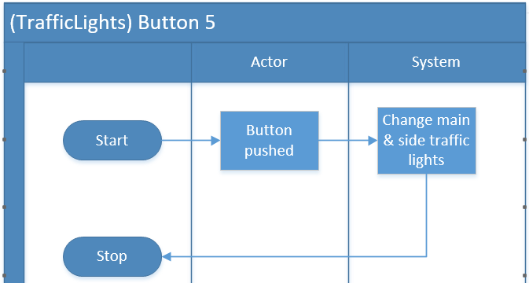

# Akkoord leidinggevende/Projectleider

|  |  |
| --- | --- |
| Naam |  |
| Datum |  |
| Handtekening |  |